**Approach Document for “Two Tile Template”**

Table of Contents

1. *Introduction:* 3

2. *Task Description:* 4

3. *UI Implementation :* 4

4. *Business Logic Implementation:* 5

5. *App changes:* 5

6. *App Server changes:* 5

7. *Web Server changes:* 5

8. *Database changes:* 5

9. *Impacted Items List:* 6

10. *Questions/Clarifications:* 6

11. *Assumptions/Dependencies/Constraints:* 7

12. *Requirement Traceability Matrix* 7

# *Introduction:*

This is the technical document which contains the details about the task and approach to implement the same in details. This document would help the team for any future reference for developing and testing.

The approach document will be prepared for all the tasks other than tasks which needs be addressed in customer priority or during production release.

All developers would be preparing this document and get it validated from Technical lead before starts the implementation.

# *Task Description:*

Two Tile Template should be able to be used for a home page or an internal page. The template needs to be configurable, where user can select the following:

* Top banner
* Background image
* Number of buttons on the page
* Image on the button

Buttons can lead to either a sub-menu, HTML link, video link, PDF page, news feed page.

* 2 images horizontally needs to be displayed in the page one below other, If more than 2 images are set then it scrolls vertically.
* The image is the full image and the text would be optional and below.
* Both topbanner image and background image are optional to the template.

# *UI Implementation :*

iPhone/Android:

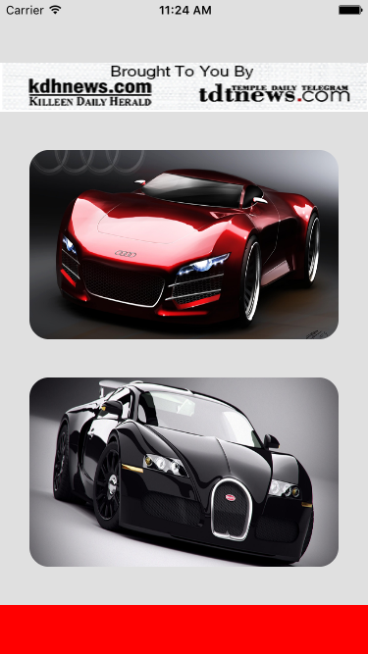 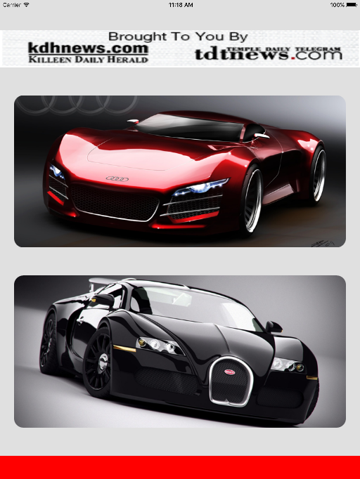

Ipad:

# *Business Logic Implementation:*

**iOS/Android:**

**2 tile image:**

* The menu displayed with custom bar, optional banner image and bottom buttons .
* By default 2 Images(**708 x 326**) will be displayed to fit the page without scrolling, If more than 2 it scrolls vertically.
* 2 Buttons per page are displayed horizontally one below other.
* If button name is present then it is displayed else it is not displayed but Space for button name will be reserved even if it is not displayed.
* Background image is optional for the template

# *App changes:*

iOS/Android:

* + Create new screen design for 2 tile Template.
  + 2 Images(**708 x 326**) will be displayed to fit the page without scrolling, If more than 2 it scrolls vertically.
  + Make the label optional.
  + Background image is optional for the template hence have to set the general background image or color if template specific image is not set.

# *App Server changes:*

<changes required in server end>

# *Web Server changes:*

# *Database changes:*

<changes required in database end>

# *Impacted Items List:*

iOS:

* Mainmenuviewcontroller.m
* buttonsetupviewconmtroller

Android:

* FourTileTemplate.java
* Four_image_tile.xml
* FilterandSortAsyTask.java
* menuAsytask.java
* menuDataHandler.java

# *Questions/Clarifications:*

|  |  |  |
| --- | --- | --- |
| SL No | Query Description | Response |
| 1. | Do we need to restrict only for two image ? If it is only one image, do we need to display in center of the screen?. | No |
| 2. | Should we have background image for this template alone ? which will override Main/Sub menu level background image | Yes |
| 3. | For this template do we need to have vertical scroll for both iOS and Android ? Currently iOS has paginated horizontal view and android has vertical scroll. | Vertical scroll on both |

# *Assumptions/Dependencies/Constraints:*

* Space for button name will be reserved even if it is not displayed
* Template specific optional background image is added

# *Requirement Traceability Matrix*

|  |  |  |  |
| --- | --- | --- | --- |
| SL No | Task Description | Test case Reference | Task Release date |
| 1. |  |  |  |
|  |  |  |  |